Information on wiring up the Manus solar systems - as supplied from CTS at Ukarumpa

Here is what the wiring board looks like when it leaves the CTS department for shipping to Manus:

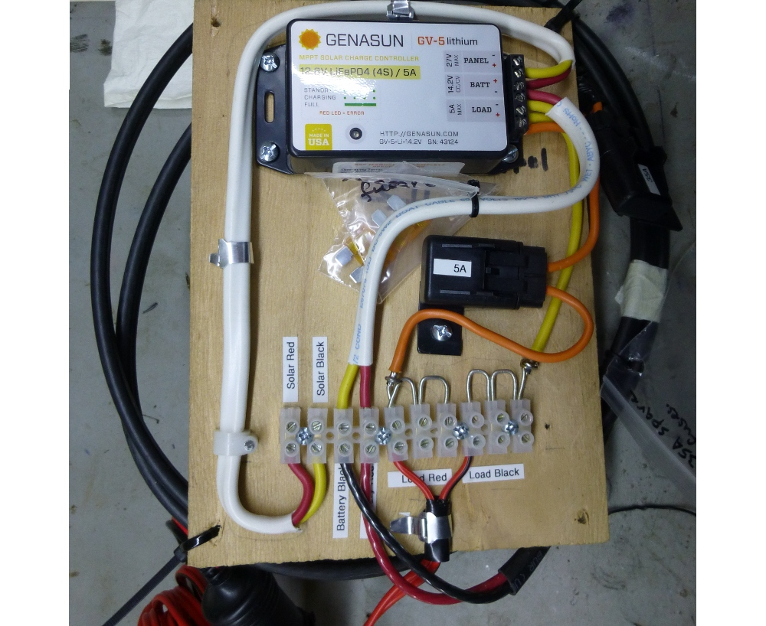
Most of the wiring is already in place on the board. Everything is clearly labeled. There are two labels that say: "Solar Red" and "Solar Black". Those two connectors are where the heavy red and black wires from the solar panel go. Use a small flat blade screw driver to loosen the set screws. Insert the red and black wires where the labels say they should go and tighten the set screws. You will probably want to screw the board to a wall inside your house.
There are extra fuses in clear plastic bags tied to the board. If a fuse ever burns out, you need to determine why, fix the problem then put a new fuse in the fuse block. If needed, only put a 5 amp fuse in the 5 amp fuse block on the wiring board, or a 35 amp fuse in the 35 amp fuse block near the battery.
There are two sets of connectors where you can hook up 12 volt devices, such as a mobile phone charger, or a 12v LED light. If you have a 12v charger for a cell phone, its wires can be trimmed and the positive wire (red) screwed into one of the "Load Red" connectors, and its negative wire (black) screwed into one of the "Load Black" connectors. You can do the same for a 12v LED light, screwing one of its wires into the "Load Red" connectors and the other one into the "Load Black" connector.

